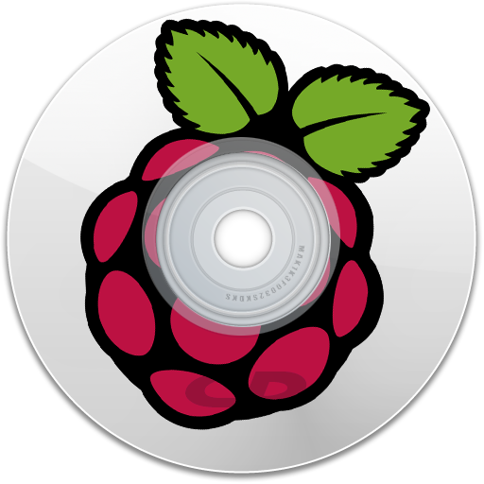

Raspberry Pi  
Music Station

Fei Yang

[hyangfeih@gmail.com](mailto:hyangfeih@gmail.com)

# What it is

Raspberry Pi Music Station is an open source project located at:

<https://github.com/fynv/RaspMusicStation>

Generally, it is a solution similar to MPD (Music Player Daemon) but specialized for Raspberry Pi.

# What can it do

After properly setup, you can use Raspberry Pi Music Station to play music from the following sources:

* Music from web
* Music from local storage
* Music from audio CD

Raspberry Pi Music Station is a headless system, while the server runs on Raspberry Pi as a daemon, all interactions are performed through an Android client App.

The client App has 4 Tabs:

|  |  |
| --- | --- |
|  |  |
| Web music | Storage music |
|  |  |
| CD music | Settings & tools |

* Web music

You can browse music web-sites in the embedded browser. When you click a download link, the link will be sent to the server and immediately downloaded and played at server side.

* Storage music

You should organize your music file at /home/pi/Music in sub-directories. Each sub-directory will be recognized as a song list. Using the client, you can touch open each song list and play the songs.

* CD Music

It works just like a CD player. Insert a disk, then touch the play button or any track.

* Settings & tools

There are not very much to setup. Just tell the client the IP number of the server, and set a homepage address for the Web Music page. And you can also send a server a Reboot or Shutdown signal here.

An interesting experimental function is that the server will emit 4 sound notes with the IP encoded, and the client App can “hear” can decode the notes so that you won’t need to type in the IP address manually. To do this, just turn on the “Listen IP” switch, and start the server and wait for the notes.

# Setup

## Hardware and connection

Besides Raspberry Pi, you still need:

* An Ethernet cable to connect your Raspberry Pi to your router. (An USB Wifi Adaptor should also work, not tested though)
* An USB CD-ROM

What I am using is a 9.5mm thick notebook DVD-RW with an USB case. Please Do use an extra power cable to power your CD-ROM, never ever try to use Pi to power it.

* A pair of loud speaker

And that’s all you need for hardware. To simplify the power supply, I’m using a powered OTG cable to power my Pi and CD-ROM at the same time:

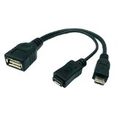

In my case, the loud speakers also need power from the USB, and I have to use another independent USB power adapter. I tried using the same one, but I got too much noise (the power circuit is polluted by the CD-ROM and the board!)

## Software

Please download all the files in <https://github.com/fynv/RaspMusicStation/Binaries>

For server side, after flashed Raspbian, you should **deploy the files:**

* **omxbyteplayer**
* **omxcdplayer**
* **omxdirplayer**
* **RaspMusicStationServer**
* **RaspMusicStationServerStarter.sh**

**and the directory:**

* **sound**

**to /home/pi on the server**

The CD playback module requires libcdio, so it is require to:

**pi@raspberrypi:~$ sudo apt-get install libcdio13**

For client side, you should **install:**

* **RaspMusicStationClient.apk**

**to your Android device**

To start the severer program, run:

**sudo RaspMusicStationServer**

using any approach you like.

For me, I want it to automatically to start during boot, so **copy**

* **RaspMusicStationServerStarter.sh**

**to /etc/init.d**

and use “update-rc.d” to setup the auto-starter.:

**pi@raspberrypi:~$ sudo update-rc.d RaspMusicStationServerStarter.sh defaults**

Now, reboot and enjoy!